**Name – Majahar Mahamud Kazi**

**Div – B Batch – B2**

**Roll no. – 322036 PRN no. – 22110729**

**Assignment 7**

**Aim:** **Deploy a web application using Docker.**

**Theory:**

1. **What is Docker ?**

Docker is a containerization platform that allows developers to package an application and its dependencies into a container that can run on any machine with Docker installed.

1. **Docker Architecture:**

Docker architecture includes three main components: the Docker daemon, the Docker client, and the Docker registry. The Docker daemon is the background service that manages the containers, images, and networks. The Docker client is a command-line interface that allows users to interact with the Docker daemon. The Docker registry is a place where Docker images can be stored and shared.

1. **Difference between Docker and Virtual machine?**

Docker is different from a virtual machine in that it shares the host operating system's kernel and doesn't require a separate operating system for each container. This means that Docker containers are much lighter and faster to start up than virtual machines.

1. **Docker Commands:**

Docker commands include docker run, docker build, docker push, docker pull, docker ps, and docker logs. These commands are used to manage Docker containers, images, and networks.

1. **Dockerfile:**

A Dockerfile is a text file that contains instructions for building a Docker image. It specifies the base image, any additional software packages to install, and any configuration settings needed for the application to run.

1. **Docker-Compose and Docker-swarm:**

Docker-compose is a tool for defining and running multi-container Docker applications. Docker-swarm is a tool for managing a cluster of Docker nodes and deploying a Docker stack to that cluster.

**Implementation:**

**Step 1: Install nginx on windows follow the link:**

<http://nginx.org/en/docs/windows.html>

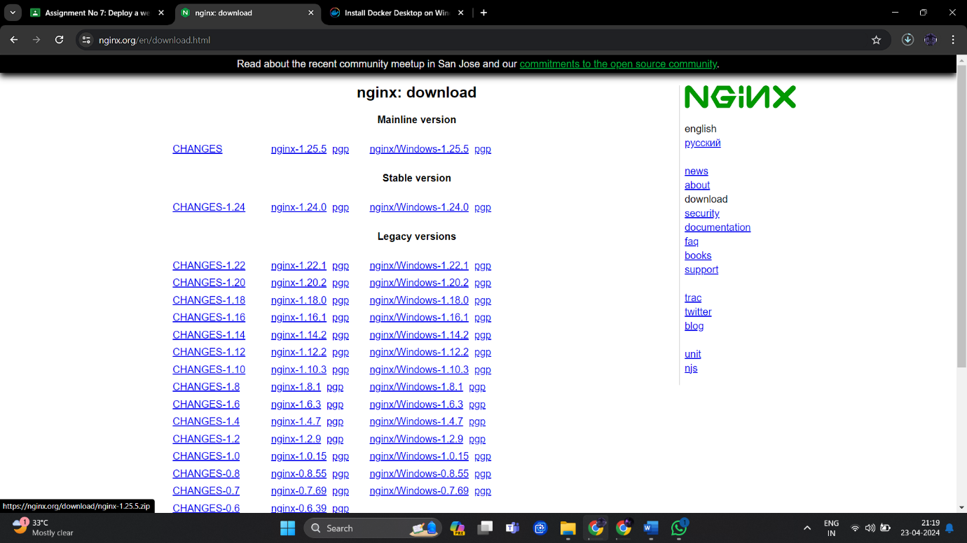

**Step 2: Copy the sample-website in “C:\nginx\html\” folder**

**Step 3: open browser and run “localhost:80”**

**Step 4: Download Docker for windows, follow the link**

<https://docs.docker.com/desktop/install/windows-install/>

**Step 5: Start Docker Desktop**

Docker Desktop does not start automatically after installation. To start Docker Desktop:

1. Search for Docker, and select Docker Desktop in the search results.

**Step 6: Open Powershell and check Docker installation using commands:**

a. docker –version

b. docker info

c. docker version –format {{json .}};

**Steps to run the “Sample website” in Docker container**

**Step 1) visit to Docker hub web site:** <https://hub.docker.com/>

**Step 2) search for “nginx” image on site**

**Step 3) pull the latest image of nginx using command**

docker pull nginx

**Step 4) check the docker images on your desktop by using command:**

docker image

**Step 5) go in the “SampleWebsite” folder and then Create a container using the docker command and sync the “SampleWebsite” folder with folder inside the container folder. (This is called Mount Bind”)**

“docker run -d -p 8001:80 -v ${PWD}:/usr/share/nginx/html --name web-site nginx”

**Step 6)verify the website open browser and chec “localhost:8001”. Now this**

website is running inside your container.

**DockerFile**

**Step 1) Create a Directory structure like**

App

Website

Dockerfile

**Step 2) Write a following script into “Dockerfile”**

**Step 3) build image from docker file using command**

“docker build -t my-app:v1 . ”

**Step 4) check images using command: docker images**

**PUSH Image to “DockerHub”**

**Step 1) login to docker hub using command**

**Step 2) docker images**

**Step 3) docker tag (old image name) majahar/newname**

docker tag my-web:v1 majahar/newapp

**Step 4) docker push majahar/newapp**

**Step 5) Login to Docker Hub and check the repository**

Congratulations!!!!

Now you can share this image with anyone with running nginx

and your web application.

Author – Majahar Kazi

Tuesday 23 April 2024 9:04:15 PM IST